A Mini Project

On

**ONLINE RENTAL WEBSITE (NOBUY.COM)**

Submitted in partial fulfilment of the Requirements for the award of the degree of

**Bachelor of Computer Application**

By

**Raju S**

(19SJE944)

**Hariharan M**

(19SJE936)

**Sunil P**

(19SJE949)

Under the guidance of

**Mrs. Annie Syrien**, Assistant Professor & HOD,

Department of Computer Application.



**ST. JOSEPH’S EVENING COLLEGE**

(AUTONOMOUS & RE-ACCREDITED BY NAAC)

Museum Road, Bengaluru – 560 025.

**ST. JOSEPH’S EVENING COLLEGE**

(AUTONOMOUS & RE-ACCREDITED BY NAAC)

Museum Road, Bengaluru – 560025.

CERTIFICATE

This is to certify that the project work entitled “**Online rental site (Nobuy.com)”** in Computer Application (mini project) being submitted by **Raju S(19SJE944)**, **Hariharan M(19SJE936)** and **Sunil P(19SJE949)** in partial fulfillment of the requirement for the award of **Bachelor of Computer Application** to ST. JOSEPH’S EVENING COLLEGE, AUTONOMOUS, BANGALORE is a record of bonafide work carried out by them under the supervision and guidance during the year 2021-2022.

REG. NO. NAME.

1. **19SJE936 Hariharan M**

2. **19SJE944 Raju S**

3. **19SJE949 Sunil P**

Date of the examination: 18-01-2022

**Head of the Department** **Project Guide**

Mrs. Annie Syrien Mrs. Annie Syrien

Examiners:

1)

2)

**ACKNOWLEDGEMENT**

We wish to express our profound gratitude to Dr. Paul Newman K. Principal of St. Joseph’s Evening College (Autonomous) for having permitted us to take up this mini project work. We owe special grateful to our Computer Application Head of the Department Mrs. Annie Syrien for her encouragement to fulfil the requirement of the project.

We consider it is great pleasure to extend our heart full gratitude to your staff members of the computer application department who provided the opportunities and spared their time in persuading us in doing this project.

We than everyone for their support and co-operation. Last but not least, we thank our parents, friends whole heartedly for the unending loveable moral support towards the successful completion of this project. Finally, we would like to thank one and all who have contributed for successful completion of this project.

**Place:** Bengaluru

**PROJECT TEAM:**

1. Raju S 19SJE944

2. Hariharan M 19SJE936

3. Sunil P 19SJE949

CONTENTS

**Topics** **Page No**

1. Abstract 1

2. Introduction 1-2

3. Existing System 2

4. Proposed System 3

5. Software Tools Specification – Project Requirements 3-6

a) Hardware Requirements 3

b) Software Requirements 4

c) Frontend Description 4-5

d) Backend Description 6

6. Modules of project 7-8

7. Flowcharts/DFD 9-11

8. Screenshot of the project 12-16

9. Testing 17-20

10. Conclusion 21

11. Future Recommendations 21

12. Bibliography or list of references 22

**ABSTRACT**

Internet Renting has become more and more popular nowadays, however, some consumers are still hesitating to purchase online due to some perceived risks. The purpose of this project is to introduce rental platform via internet shopping, trying to analyze problems facing it and find corresponding solutions to ensure e-commerce growth.

**INTRODUCTION**

Our project (Nobuy.com) is to create a prototype of an online rental platform which makes it cost effective for the consumers to experience the product without purchasing the product.

This project aims to develop an online renting platform for the customers with the intention of using the product for a temporary time period so that it is easy to rent them for a minimal cost compared to purchasing them. With the help of this you can order products from your home. Also renting a product allows consumer to try out product before purchasing it. We have multiple range of products for the consumer to choose from.

Page 1

To get to this online rental system all the customers will need to have an email and password to login and proceed your renting. The login credentials for an online renting system are under high security and nobody will have the capacity to crack it easily.

Upon successful login the customers can order for things such as Furniture, Electronics, Clothing, Jewellery etc. can be rented using Nobuy.com renting system. And the consumer will get the ordered items at their door step.

**EXISTING SYSTEM**

With the growing renting trend, we still lack an integrated platform for variety of products.

Current system has a lot of drawbacks such as multiple platforms for each type of product which makes it difficult to handle and confusing to the users.

Different stages for each sort of item which makes it hard to deal with and confounding to the clients.

Page 2

**PROPOSED SYSTEM**

Our effort is to focus on providing a vast range of products under one roof therefore limiting ourselves to one city at a time which helps us provide better quality of service resulting in satisfied customers.

Also, as our services are limited to one city for now which makes it easy for us deliver the product to the customers swiftly compared to other competitors in this newly growing sub sector of e-commerce.

Our rental duration is flexible and depends on the product’s general requirement of the consumers for example some products will be used for months and some will be used only for few days.

**Software Tools Specification – Project Requirements**

**Hardware requirements:**

* 4 /8 GB RAM
* Windows 7, 8 and 10

Page 3

**Software Requirements:**

* HTML
* CSS
* JAVASCRIPT
* PHP
* MY SQL
* XAMPP SERVER
* APACHE SERVER

**Front End:**

**Html:**

• HTML stands for Hyper Text Markup Language

• HTML describes the structure of Web pages using markup

• HTML elements are the building blocks of HTML pages

• HTML elements are represented by tags

• HTML tags label pieces of content such as "heading", "paragraph", "table", and so on

• Browsers do not display the HTML tags, but use them to render the content of the page

Page 4

**CSS:**

Cascading Style Sheets (CSS) is a simple mechanism for adding style (e.g., fonts, colors, spacing) to Web documents. HTML, Hyper Text Markup Language, gives content structure and meaning by defining that content as, for example, headings, paragraphs, or images. CSS, or Cascading Style Sheets, is a presentation language created to style the appearance of content—using, for example, fonts or colors.

**JavaScript:**

JavaScript, often abbreviated JS, is a programming language that is one of the core technologies of the World Wide Web, alongside HTML and CSS. Over 97% of websites use JavaScript on the client side for web page behavior, often incorporating third-party libraries.

**Features of JavaScript**

* Object-Centered Script Language.
* Validation of User's Input.
* Interpreter Centered.
* Ability to perform In Built Function.
* Case Sensitive format.
* Light Weight and delicate.

Page 5

**Back End:**

**Php:**

PHP is an acronym for "PHP: Hypertext Preprocessor". PHP is a widely-used, open source scripting language. PHP scripts are executed on the server. PHP is free to download and use. PHP files can contain text, HTML, CSS, JavaScript, and PHP code. PHP code are executed on the server, and the result is returned to the browser as plain HTML.

• PHP files have extension ".php"

• PHP can generate dynamic page content

• PHP can create, open, read, write, delete, and close files on the server

• PHP can collect form data

• PHP can send and receive cookie

Page 6

**Modules of project**

**Home page:**

This is the face of the project which contains an automatic and a manual products category slider.

**Login page:**

This page takes the login credentials of the user and the admin.

**Navigation bar:**

Navigation bar has animated dropdown menu and is present in all the pages and is interlinked to all the pages.

**Products category pages:**

This page shows the categories of the products which can be chosen individually by the user.

**Products list pages:**

These pages show the list of the selected category products.

Page 7

**Offers page:**

This page displays the current offers going on the website.

**Contact page:**

This page displays the contact details of the

**About Us page:**

This page displays the information about us and the project.

Page 8

**Data Flow Diagram (DFD):**

**DATA FLOW DIAGRAM NOTATION**

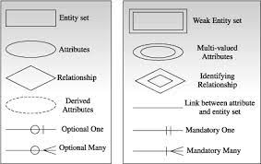

**Data Flow Diagram:**

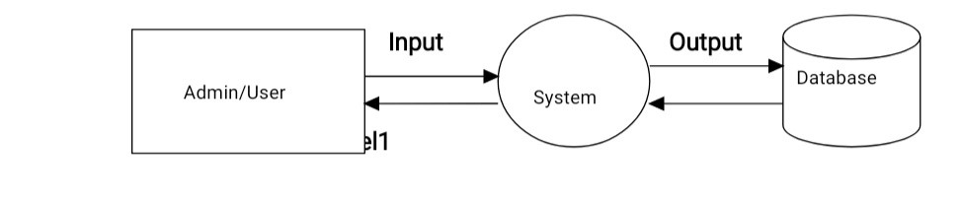

Page 9

**Entity Relationship Diagram (ERD):**



Page 10

**Future ERD:**

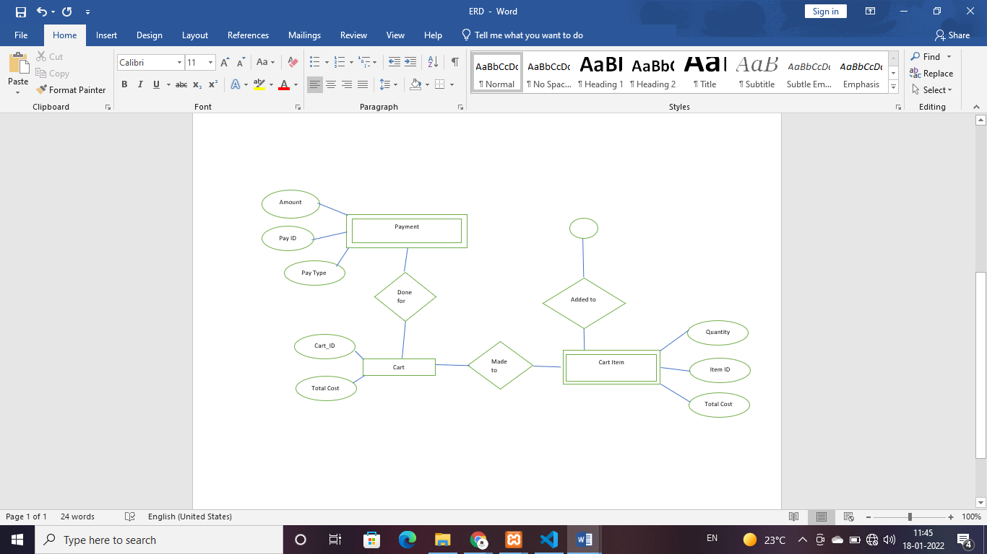

Page 11

**Screenshots:**

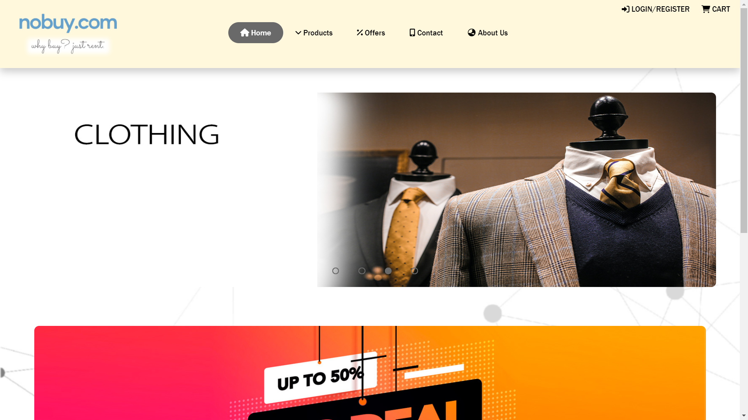

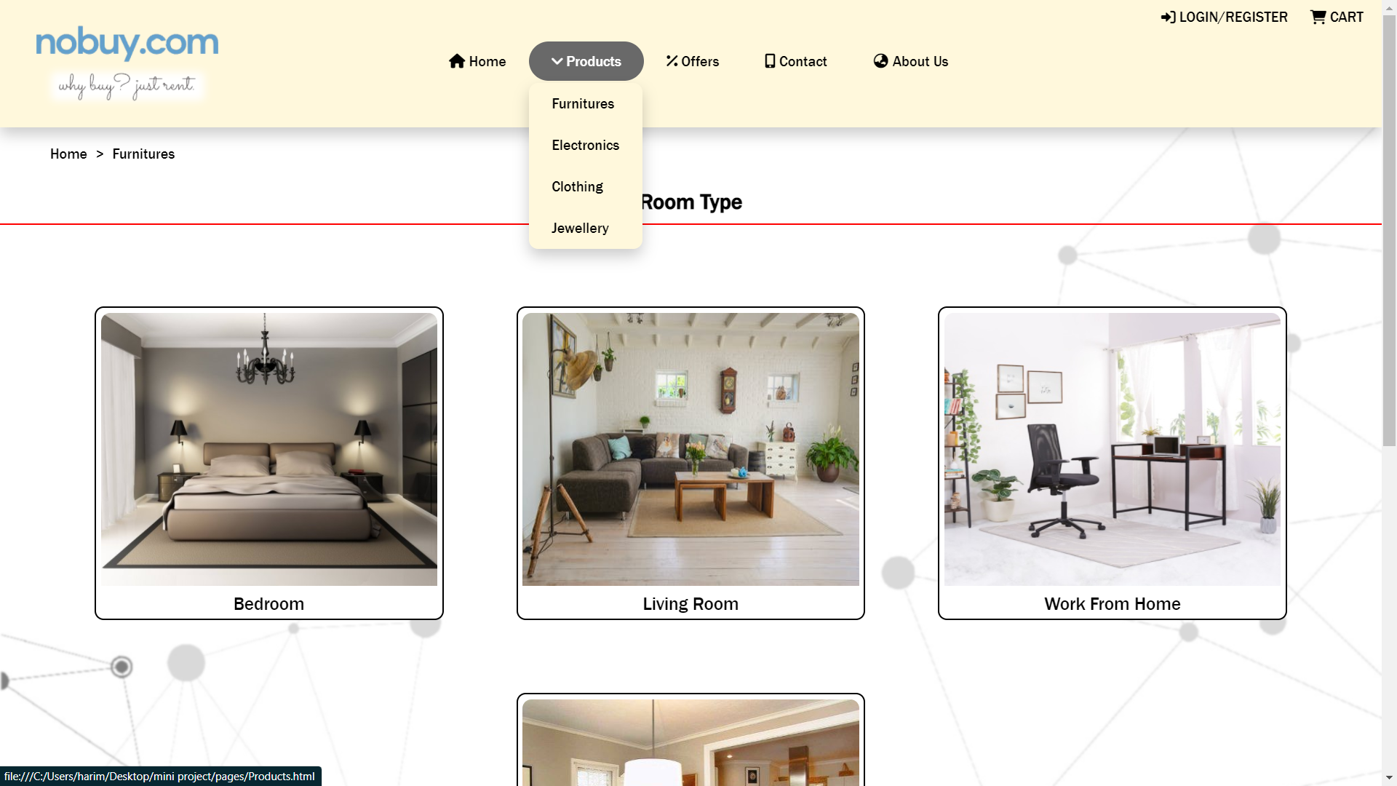

Page 12

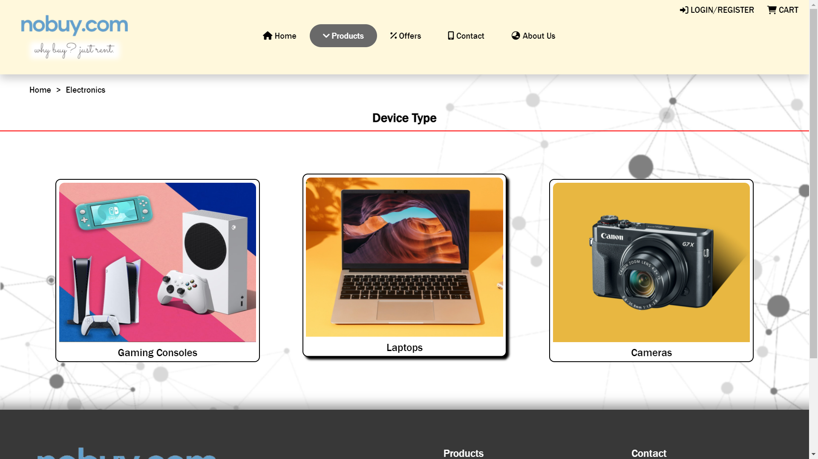

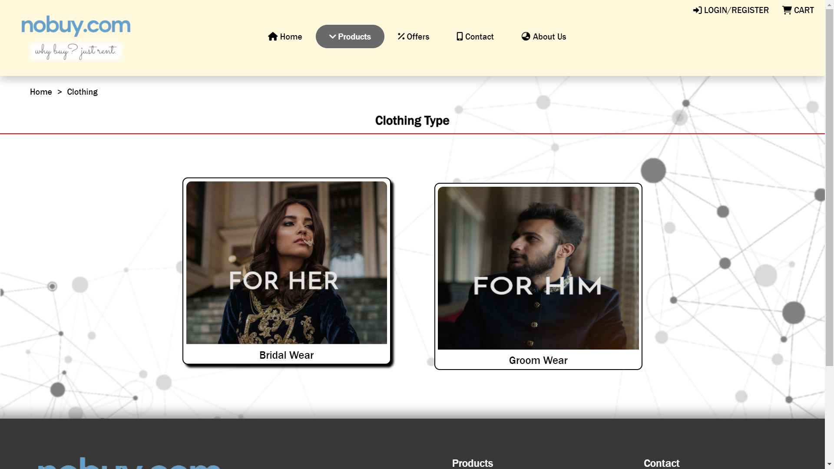

Page 13

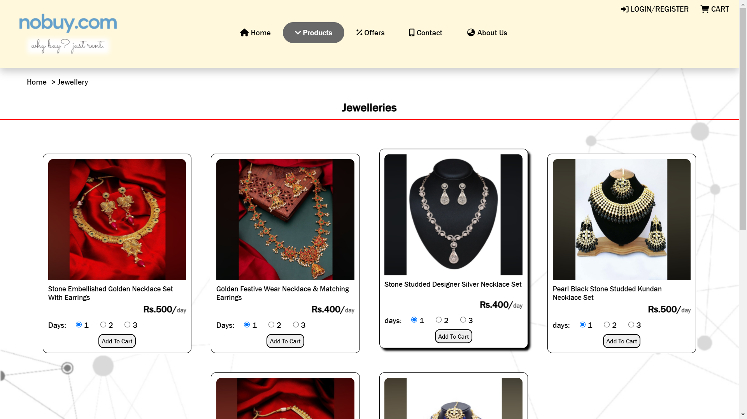

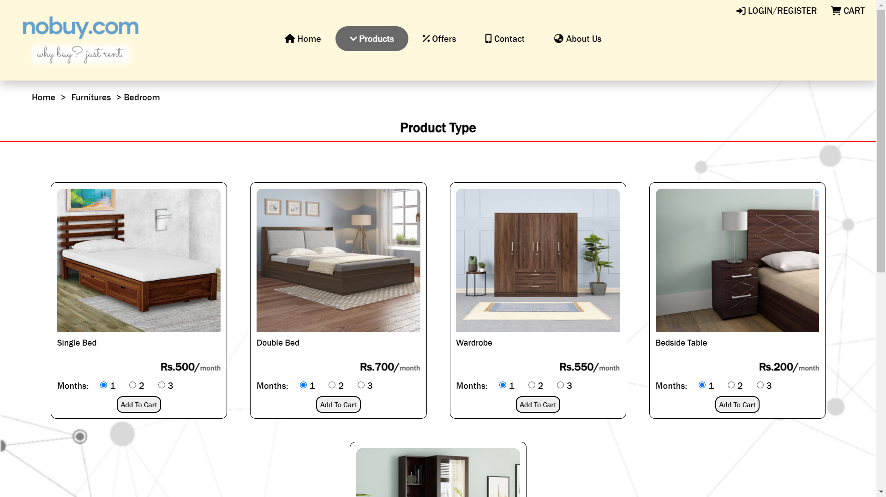

Page 14



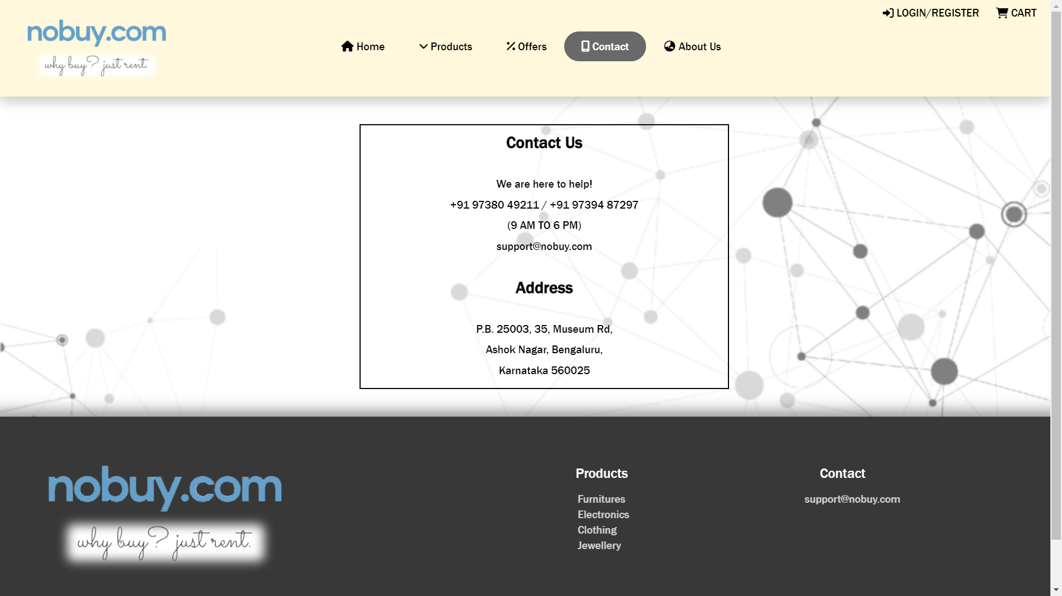

Page 15

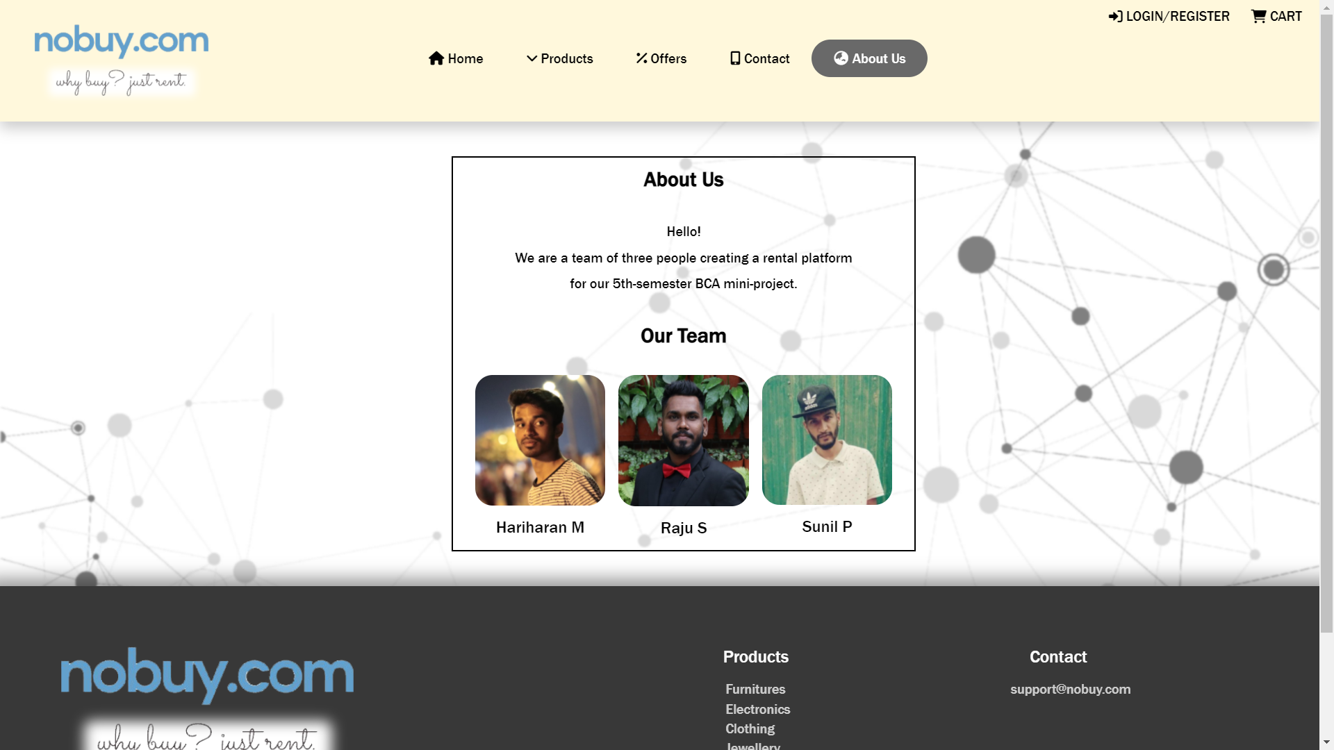



Page 16

**Testing:**

This project is completely based on the Waterfall model Testing strategy as per the client details we use to add the as per the guidelines of the client and it has been working fine. The Waterfall model is the earliest SDLC approach that was used for software development. The waterfall Model illustrates the software development process in a linear sequential flow. This means that any phase in the development process begins only if the previous phase is complete. In this waterfall model, the phases do not overlap. As an internal process, the Waterfall methodology focuses very little on the end user or client involved with a project. Its main purpose has always been to help internal teams move more efficiently through the phases of a project, which can work well for the software world. The Waterfall methodology—also known as the Waterfall Model—is a sequential software development process, where progress flows steadily toward the conclusion (like a waterfall) through the phases of a project (that is, analysis, design, development, testing). The exact number of phases needed to develop the product can be varied by the project manager depending upon the project risks.

Page 17

OUR PROJECT IS MAINLY BASED ON THE WATERFALL MODEL



➢ Requirements analysis and specification: The aim of the requirement analysis and specification phase is to understand the exact requirements of the customer and document them properly. This phase consists of two different activities.

➢ Design: The aim of the design phase is to transform the requirements specified in the SRS document into a structure that is suitable for implementation in some programming languages.

➢ Implementation: During this phase, design is implemented. If the SDD is complete, the implementation or coding phase proceeds smoothly, because all the information needed by software developers is contained in the SDD.

Page 18

➢ Testing: This phase is highly crucial as the quality of the end product is determined by the effectiveness of the testing carried out. The better output will lead to satisfied customers, lower maintenance costs, and accurate results. Unit testing determines the efficiency of individual modules. However, in this phase, the modules are tested for their interactions with each other and with the system.

➢ Maintenance: Maintenance is the most important phase of a software life cycle. The effort spent on maintenance is 60% of the total effort spent to develop a full software. There are basically three types of maintenance: Advantages of Waterfall model

➢ This model is simple to implement also the number of resources that are required for it is minimal.

➢ The requirements are simple and explicitly declared; they remain unchanged during the entire project development.

➢ The start and end points for each phase is fixed, which makes it easy to cover progress.

➢ The release date for the complete product, as well as its final cost, can be determined before development.

Page 19

➢ It gives easy to control and clarity for the customer due to a strict reporting system. Disadvantages of the Waterfall model

➢ In this model, the risk factor is higher, so this model is not suitable for more significant and complex projects.

➢ This model cannot accept the changes in requirements during development.

➢ It becomes tough to go back to the phase. For example, if the application has now shifted to the coding phase, and there is a change in requirement, it becomes tough to go back and change it

➢ Since the testing is done at a later stage, it does not allow identifying the challenges and risks in the earlier phase, so the risk reduction strategy is difficult to prepare

Page 20

**Conclusion**

Our project helps in fulfilling that need and provide those services to their doorstep which makes it hassle free for the customers.

The purpose of this project is to ease out the process of renting a product for any customer who is not interested to spend big money on products which can be rented out for a temporary usage.

Currently we have created only a prototype of the website to show how it can used as an example.

**Future Recommendations**

As mentioned this is just a prototype of a static website, our future plan is to develop a completely responsive and dynamic website with

* Online billing process
* Automated chat bot
* Responsive search bar
* Filters
* And few more products.

Page 21

**Bibliography**

<https://www.rentomojo.com>

<https://www.w3schools.com/css/>

<https://www.w3schools.com/html/default.asp>

<https://www.w3schools.com/js/default.asp>

<https://www.codingsnow.com/2021/05/tutorial56.html>

Page 22